Nu merită să riști!
Iunie
2019

Luna națională a informării despre efectele consumului de alcool

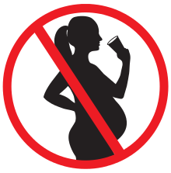

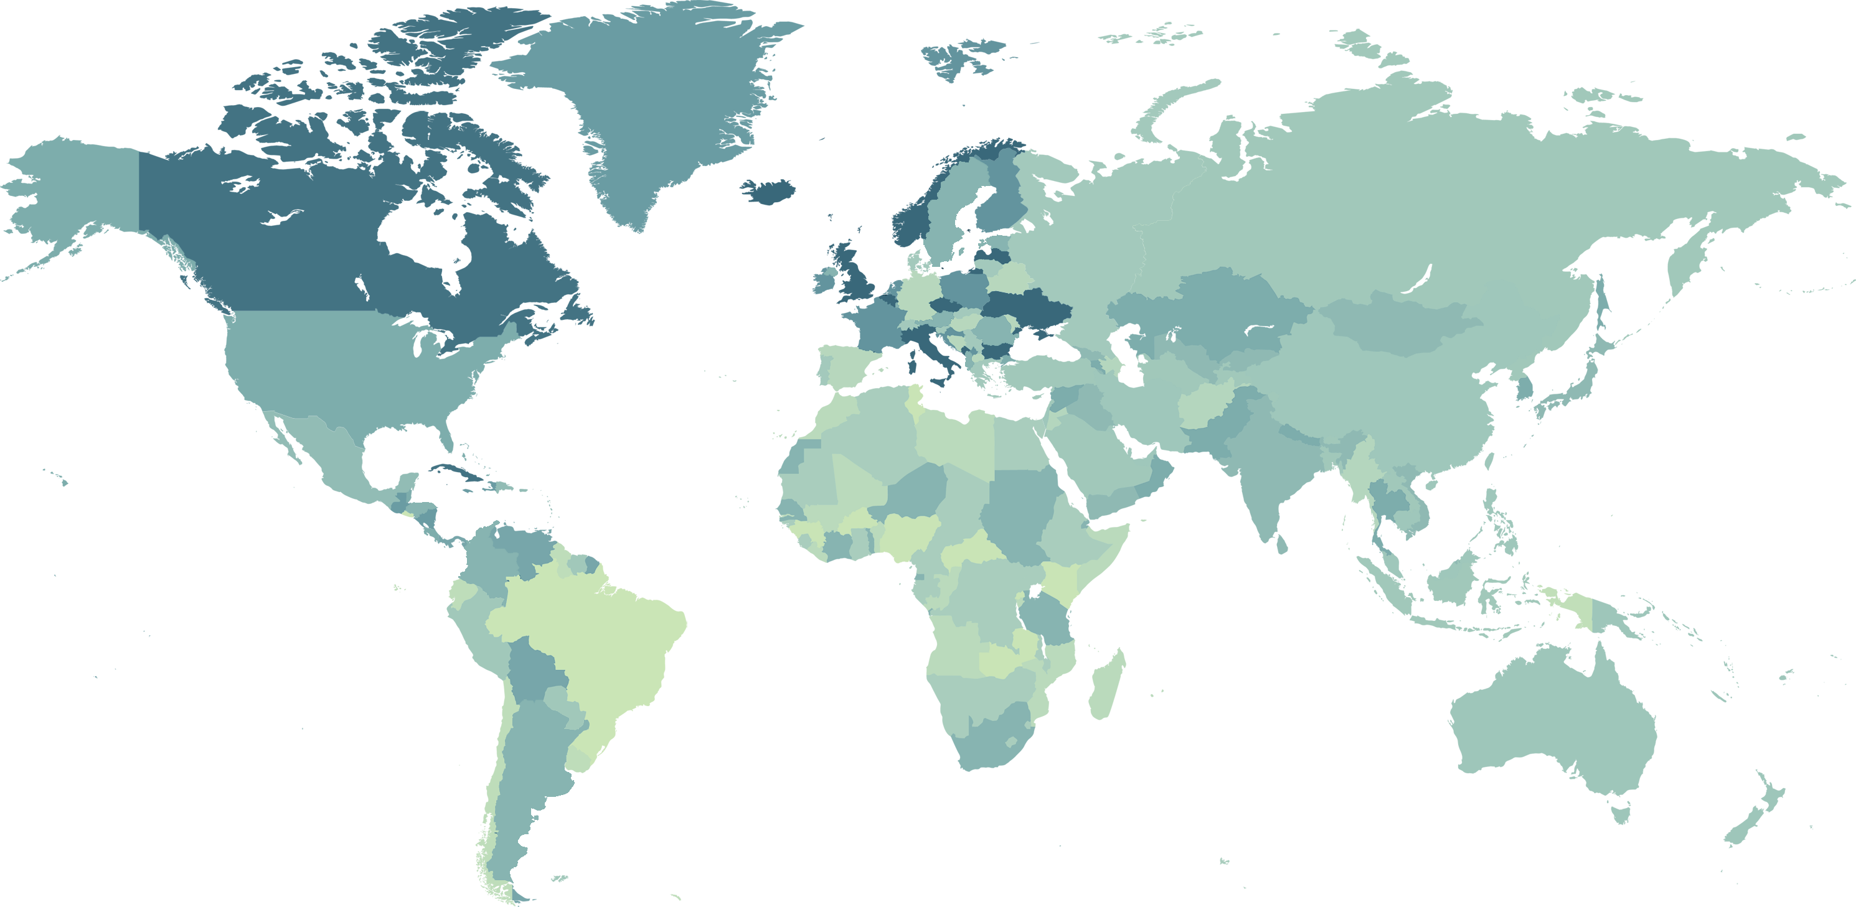

Consumul de alcool (litri alcool pur/capita 15 ani +/an)^{[4]}

O unitate de alcool =
12 grame alcool pur

Tinerii sub 18 ani și gravidele
nu ar trebui să consume alcool!

11,2 litri
Europa/UE

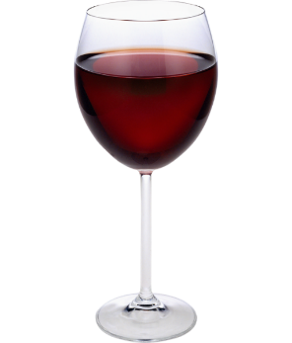

9,7 litri
America de Nord

=
=

6,6 litri
Asia de Est și Pacific

330 ml bere 125 ml vin 40 ml tărie
Alcoolul la copii și tineri sub 18 ani

Alcoolul la gravide
6,4 litri
GLOBAL

6,9 litri
America latină

6,3 litri
Africa Subsahariană

10,6 litri
Australia

- 80% din tinerii de 15-16 ani au consumat alcool cel puțin o dată în viață: 8 din 10 băieți, 7 din 10 fete^{[1]}
- 35% au un consum episodic excesiv (≥ de 5 porții la bărbați sau 4 porții la femei): 4 din 10 băieți, 3 din10 fete^{[1]}
- 50% au început să bea de la vâsta de13 ani: 6 din 10 băieți, 4 din 10 fete^{[1]}

- 1 din 10 gravide consumă alcool^{[3]}
- 20% din acestea au un acestea consum excesiv^{[3]}

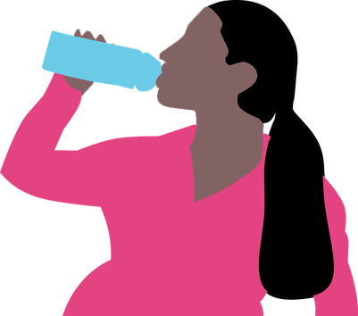

consum alcool
80% din bărbați
55% din femei^{[4]}
consum excesiv
67% din bărbați
31% din femei^{[4]}
12,6 litri
România
15 ani+

- complicații pe durata sarcinii
(moartea fătului, avort spontan, naștere prematură, greutate mică la naștere a nou-născutului)^{[4]}

GLOBAL

ROMÂNIA

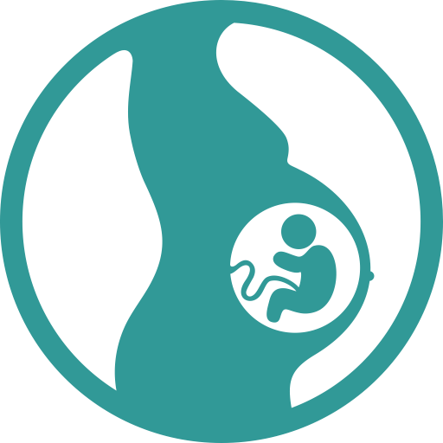

- o treime din decesele tinerilor de 11-15 ani se produc prin accidente rutiere datorate alcoolului^{[2]}
- 12% au probleme cu prietenii sau familia, rezultate slabe la școală^{[2]}
- 8% au comportamente de risc (sexual, delicvență, violență)^{[2]}

Prevalența tulburărilor fătului datorate consumului de alcool în timpul sarcinii (la 10.000 locuitori) ^{[4]}

- 428 de tipuri de tulburări de dezvoltare fizică și psihică a copilului^{[4]}
- 77,3 copii cu tulburări la 10.000 de locuitori^{[4]}
- sindromul alcoolic fetal (SAF) = forma cea mai gravă de tulburare
- 1 din 67 de gravide care consumă alcool va naște un copil cu SAF^{[3]}
- 119.000 de copii cu SAF se nasc în fiecare an^{[3]}

14,1
Asia de Sud-Est

198,2
Europa

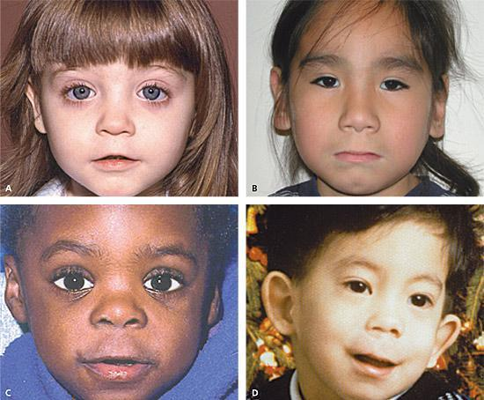

GLOBAL

87,9
America
de Nord și
de Sud

- peste 200 de boli (tulburări ale sistemului nervos, ciroză hepatică, unele forme de cancer etc.)^{[2]}
- risc de asociere a altor substanțe de abuz (tutun, droguri) ^{[2]}
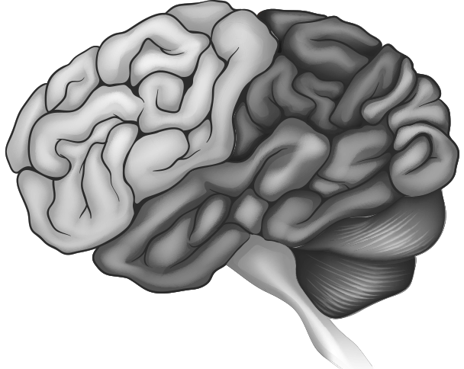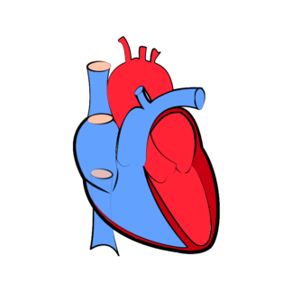
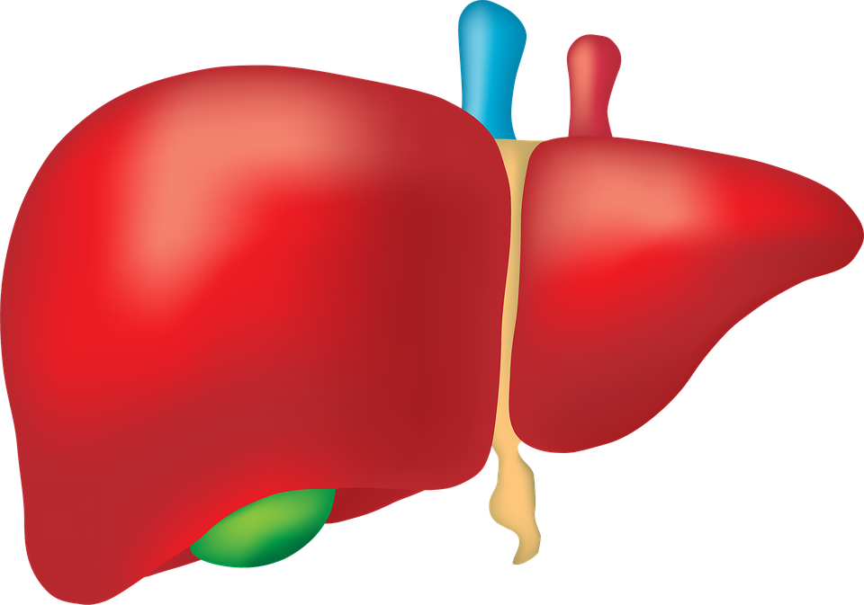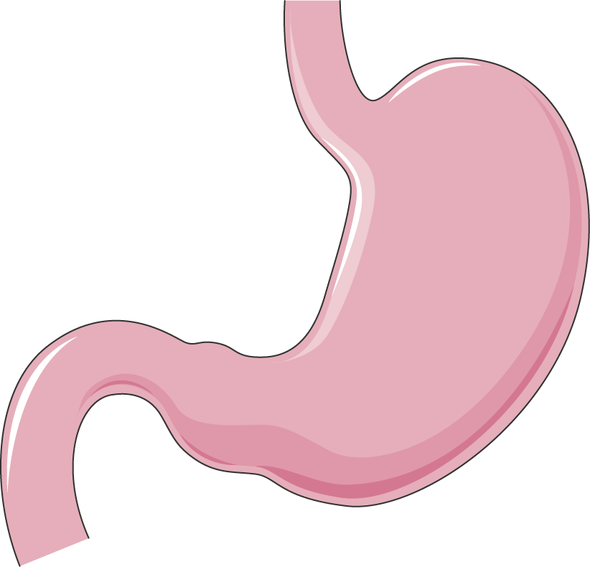
67,4
Reg. Pacificului de Vest

SINDROM
ALCOOLIC FETAL

78,3
Africa

1,3
Reg. Mediteranei de Est

77,3
GLOBAL

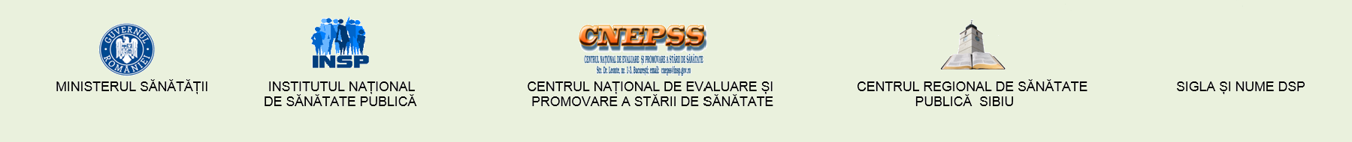

Material realizat în cadrul subprogramului de evaluare şi promovare a sănătăţii şi educaţie pentru sănătate al Ministerului Sănătății - pentru distribuție gratuită
Luna națională a informării despre efectele consumului de alcool

Iunie
2019
Nu merită
să riști!

Referințe bibliografice:

¹ESPAD (2015). Report 2015. Results from the European School Survey Project on Alcohol and Other Drugs.Luxemburg: Publ Off UE, 2016:34,38,55; http://www.espad.org/sites/espad.org/files/ESPAD_report_2015.pdf.
²Steffens, R. & Sarrazin, D. (2016) Guidance to reduce alcohol-related harm for young people. Background paper. Münster: LWL-Coordination Office for DrugRelated Issues:34,38,55; http://www.rarha.eu/Resources/...WP5.T3.YoungPeople.pdf.
³Popova S. (2017) Counting the costs of drinking during pregnancy. In Bulletin of Health Organization 2017; http://dx.doi.org/10.2471/BLT.17.030517
⁴Global status report on alcohol and health 2018; Geneva: World Health Organization:5,6, 284; Licence: CC BY-NC-SA 3.0 IGO. https://apps.who.int/iris/bitstream/handle/10665/274603/9789241565639-eng.pdf?ua=1.

